**Think… Notice… Wonder…**

By asking ***What do you notice? What do you wonder?*** we give students opportunities to see problems in big-picture ways, and discover multiple strategies for tackling a problem. Self-confidence, reflective skills, and engagement soar, and students discover that the goal is not to be "over and done," but to realize the many different ways to approach problems.

**How does it work?**

As math teachers, we it can be challenging to find open ended, multi-response topics for our kids to write about. Sometimes the best way to encourage creativity and exploration is simply posting an image and asking students to describe what they *think, notice*, and *wonder* about what they are seeing.

**How can use utilize and practice this with your student?**

In the document below, you will find several images that you can use for a “ think, notice, wonder” exercise. Students can either write their thoughts down or share them in a conversation with you. I encourage you to share your thoughts and ideas with your children as well. Since this is an open ended activity where each perspective brings something different to the table, family members of all ages can participate!

See the same below for sample responses:



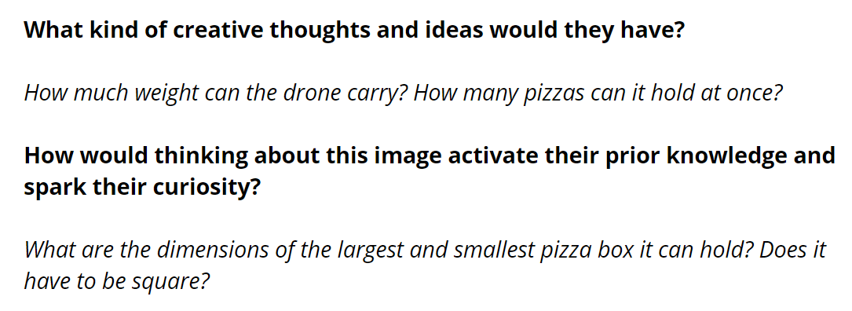

I think… I notice… I wonder… 



I think… I notice… I wonder…

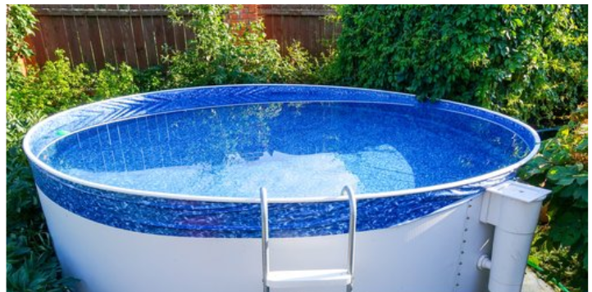



I think… I notice… I wonder…





I think… I notice… I wonder…

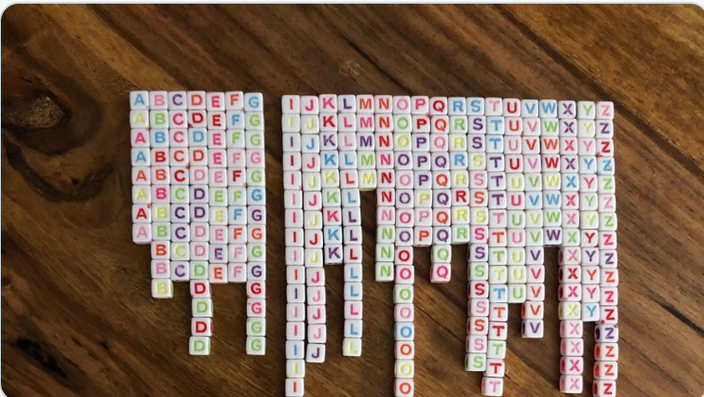

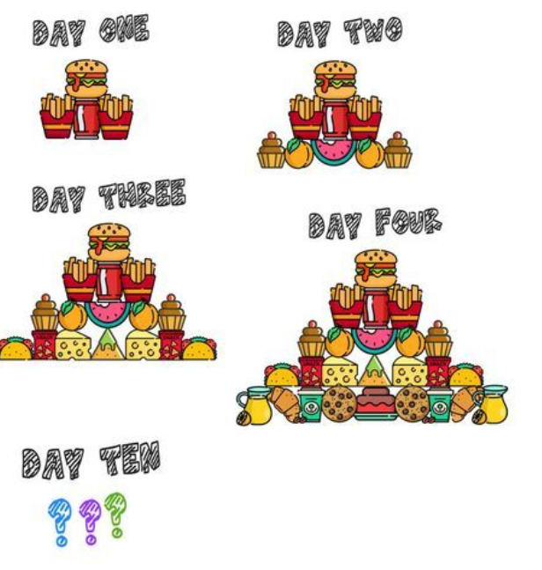

I think… I notice… I wonder…



